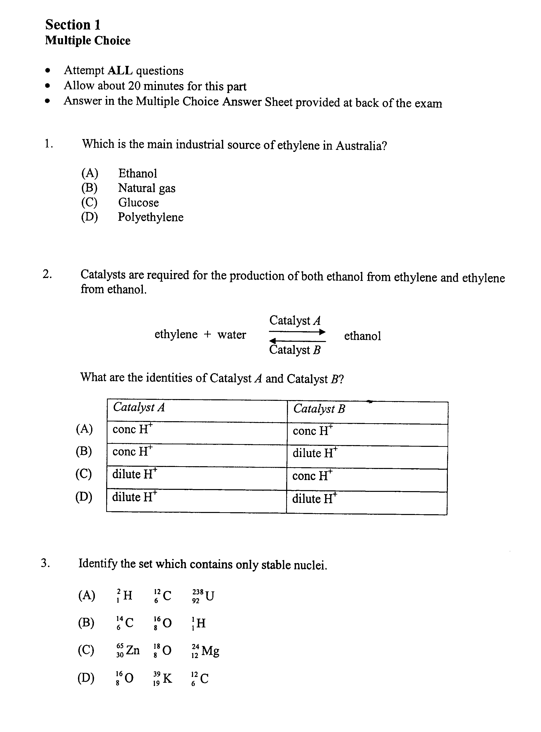
GEORGES RIVER COLLEGE OATLEY SENIOR CAMPUS – 2007 HALF YEARLY EXAM

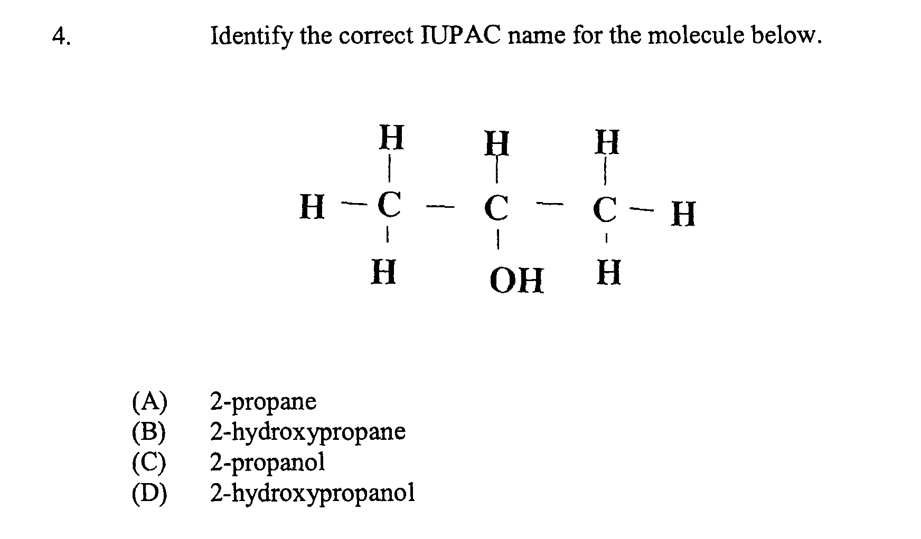

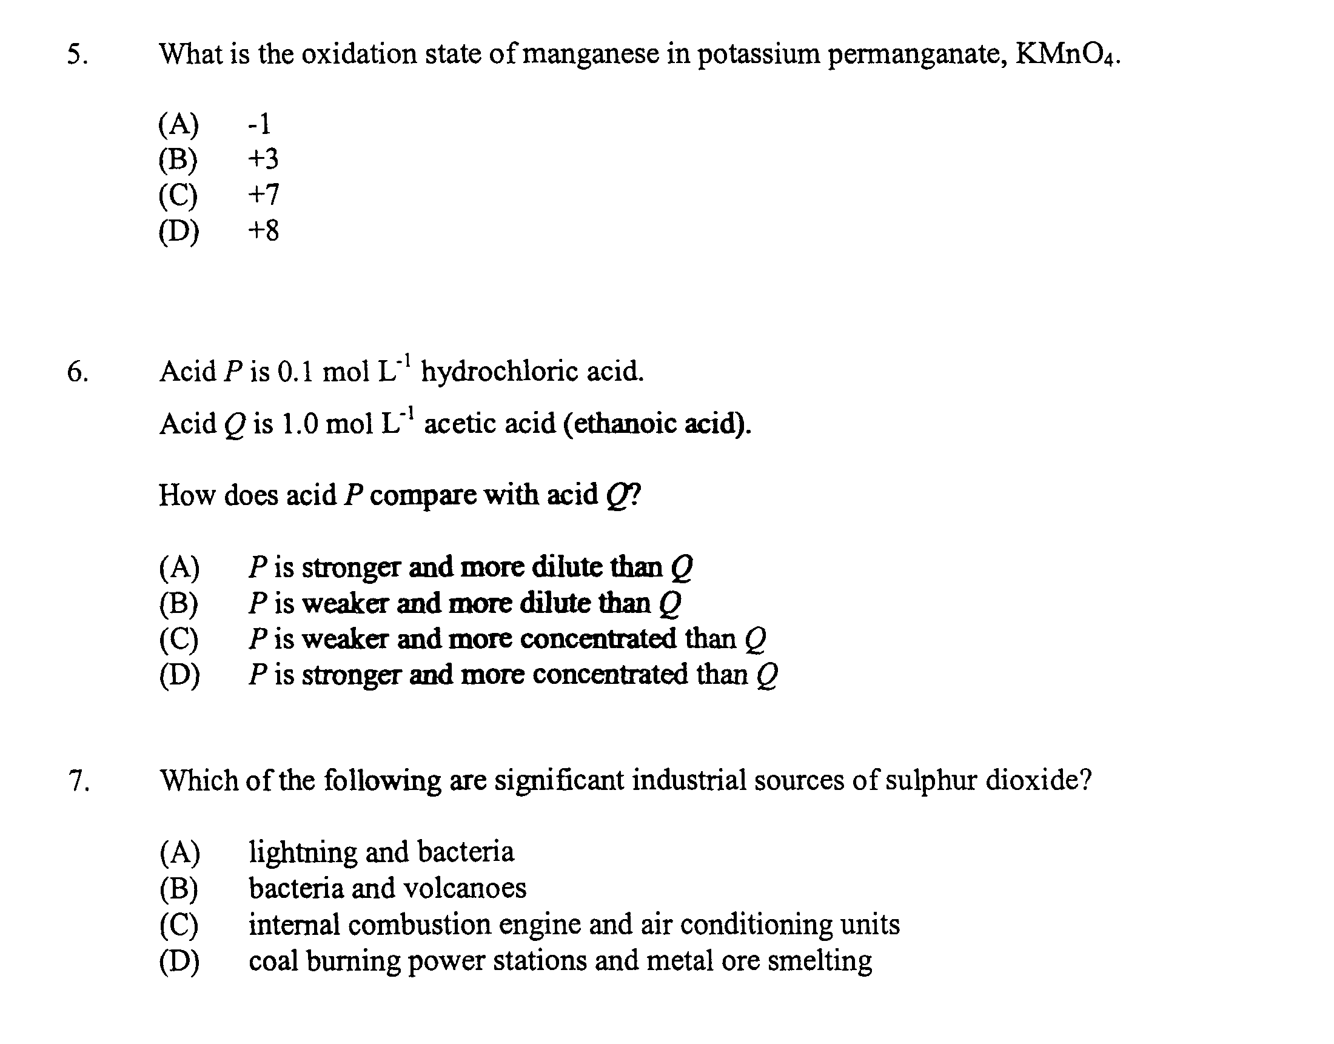

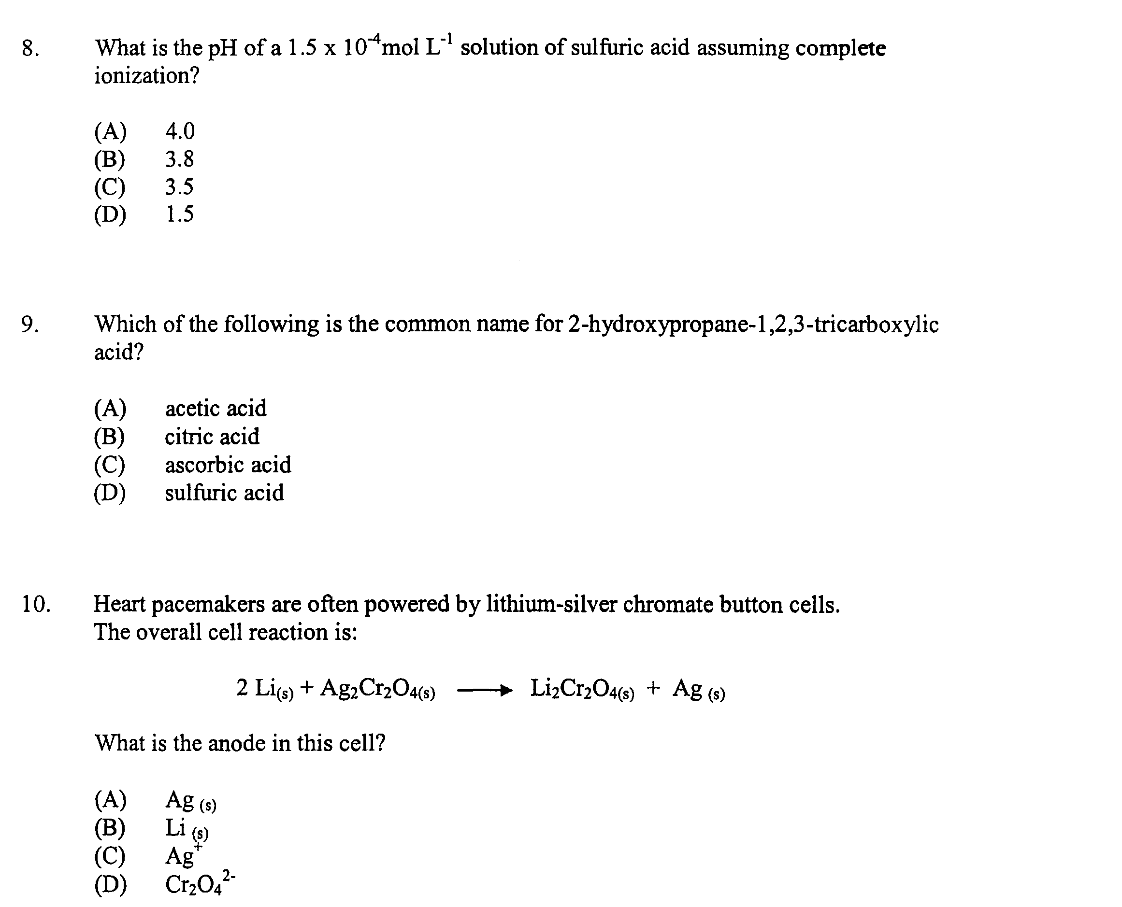

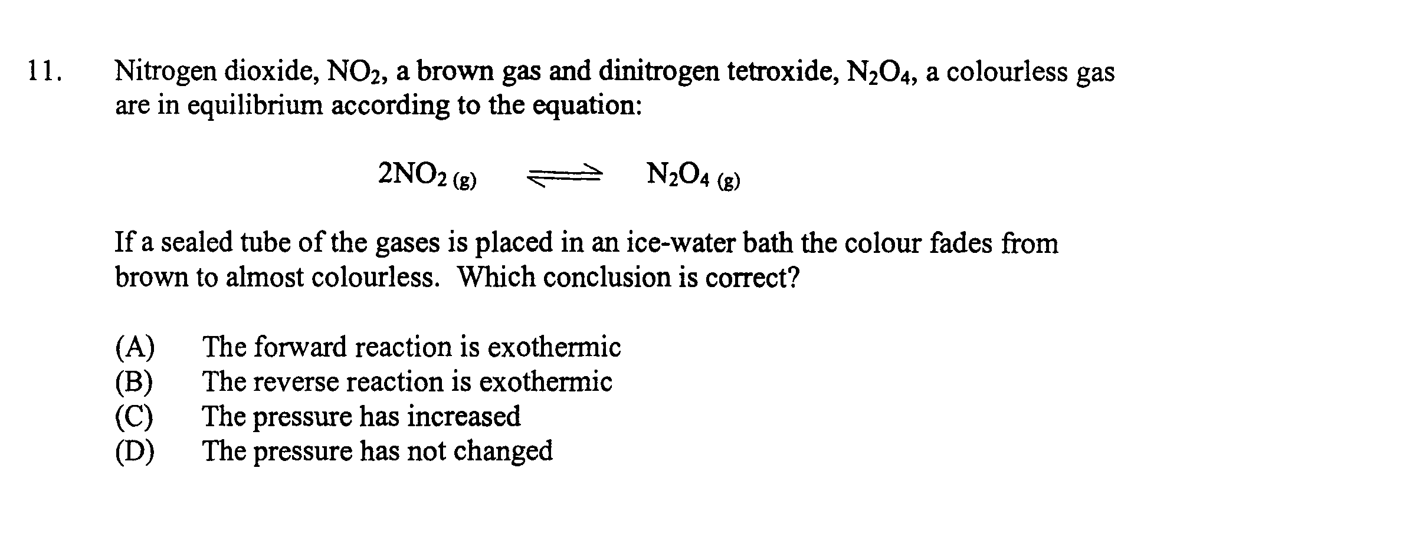

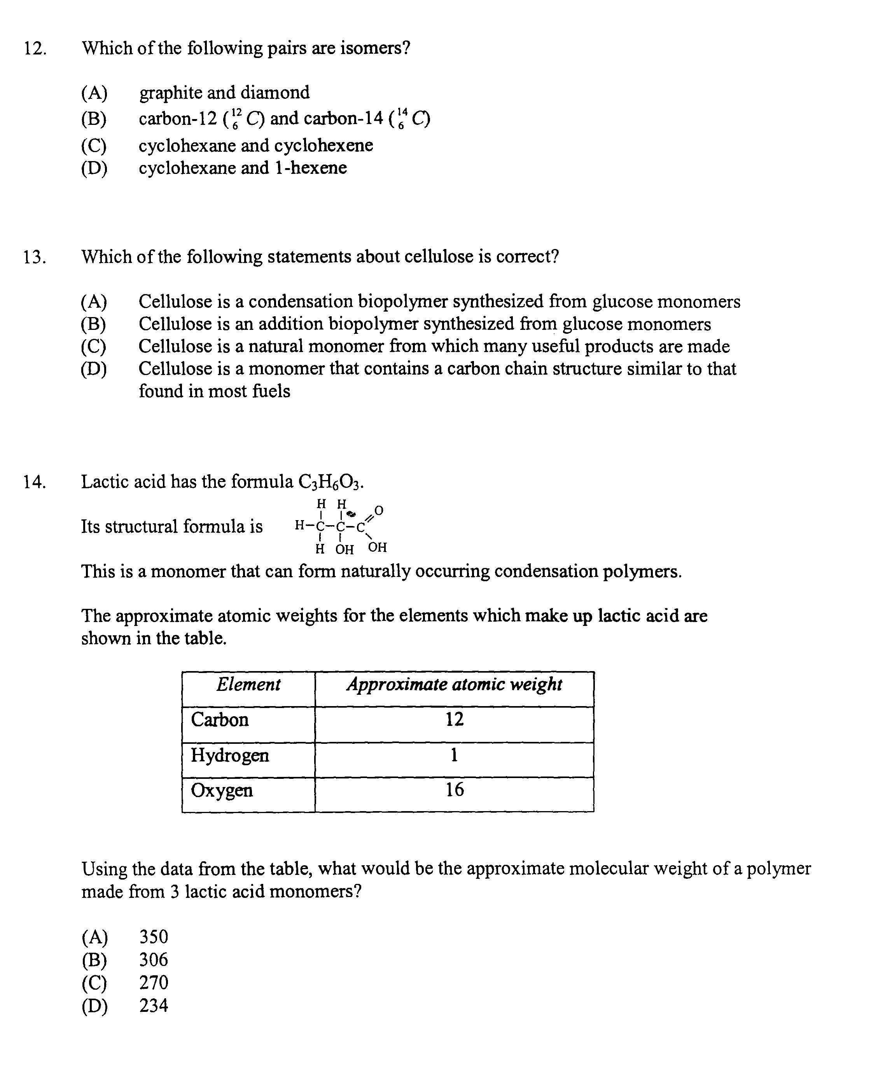

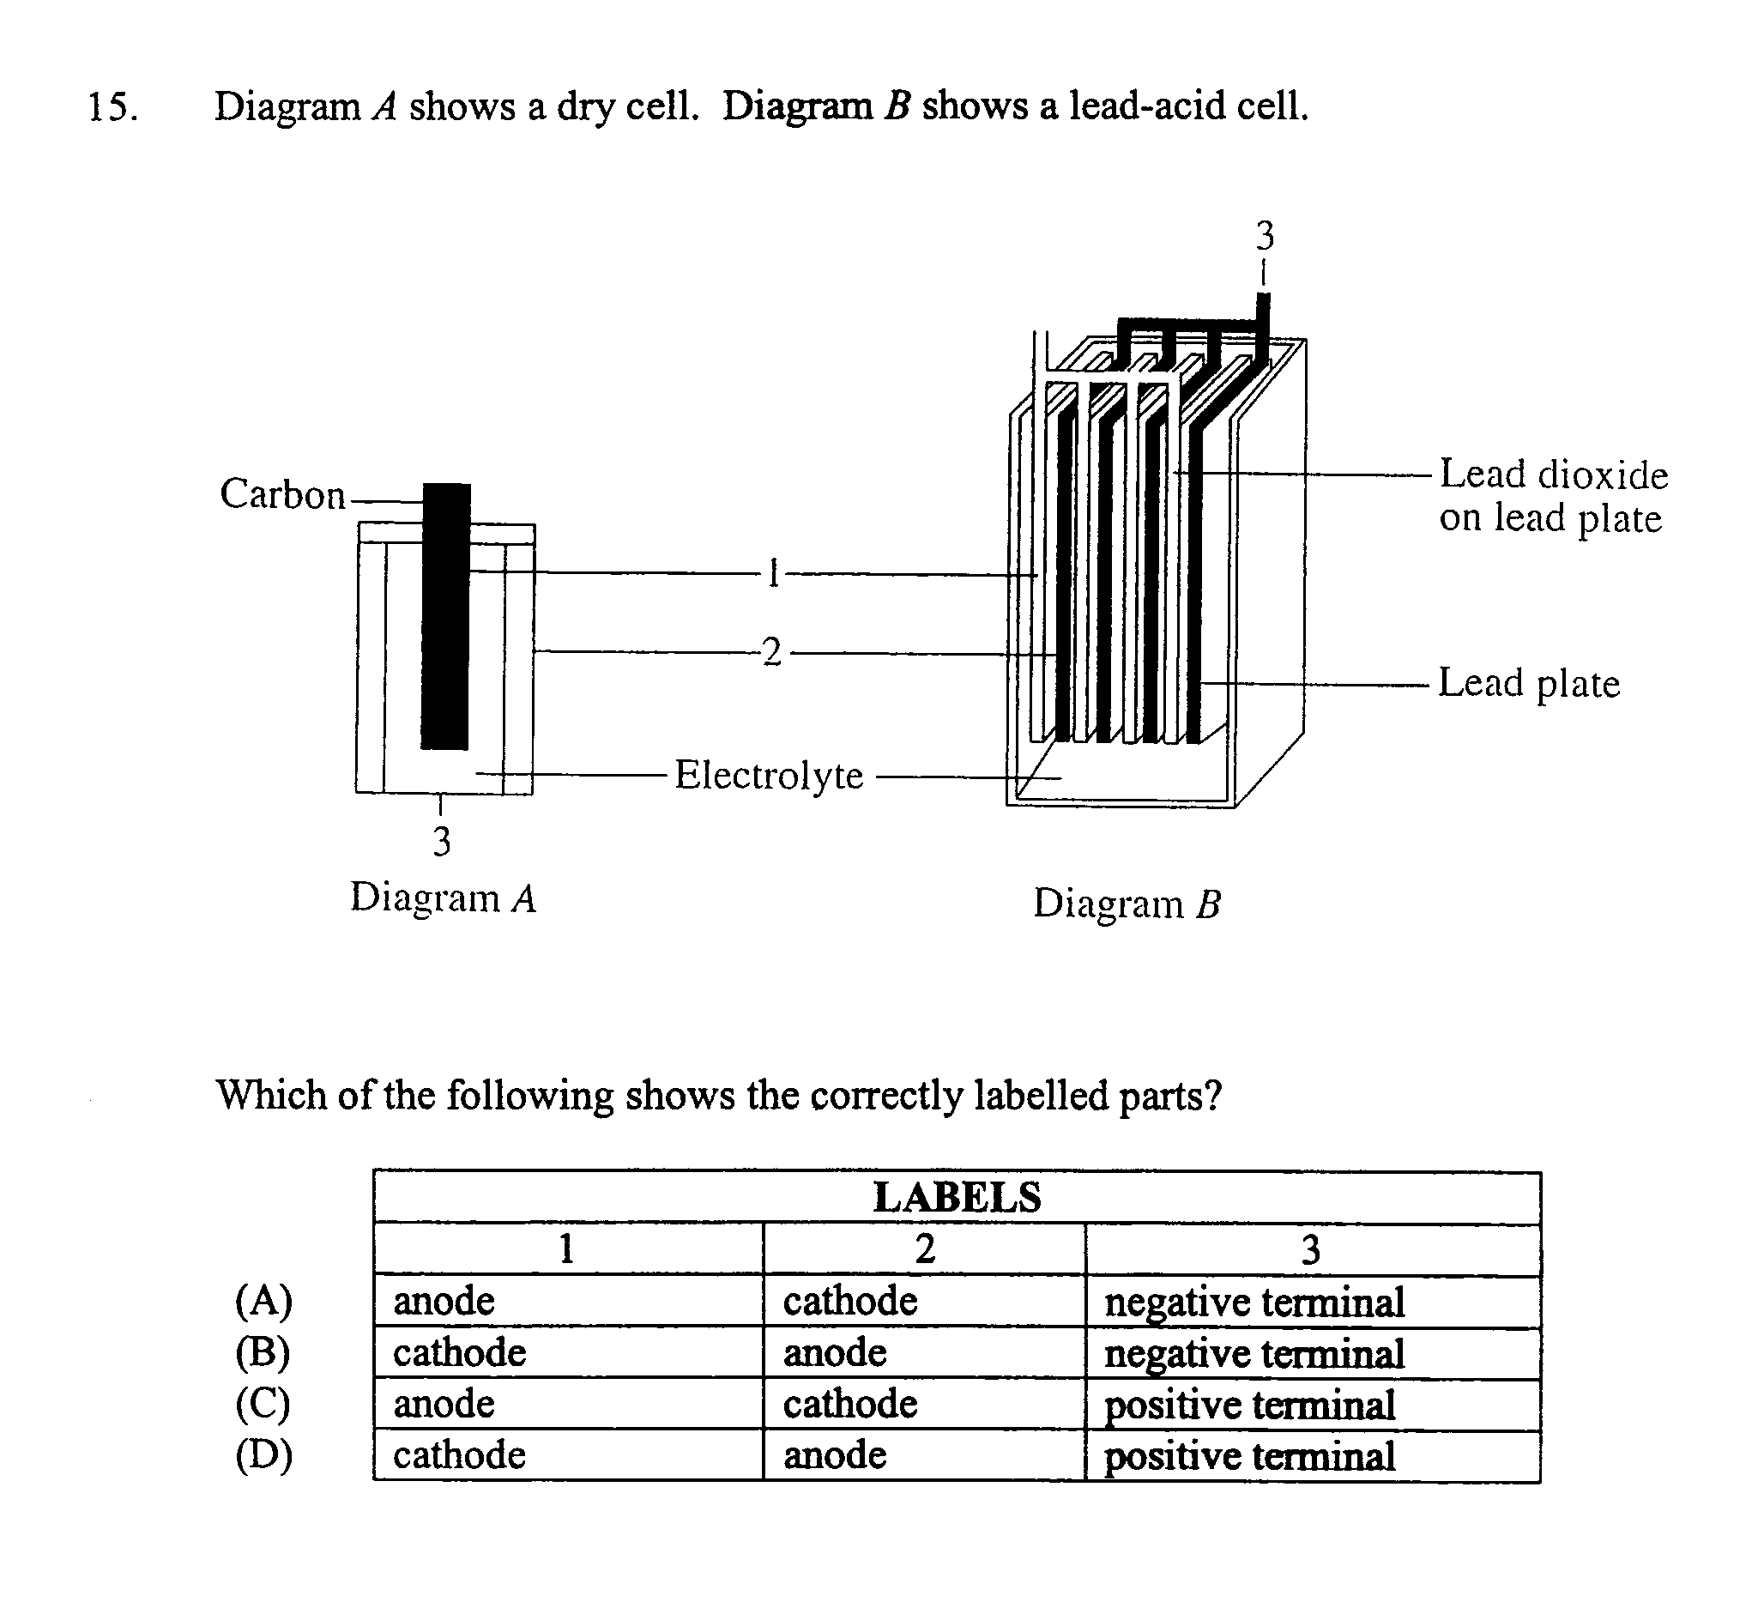

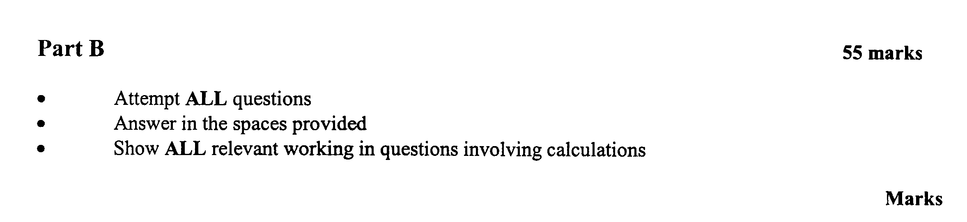

Question 16 (4 marks)

The atmosphere contains acidic oxides of sulfur which have been increasing in concentration since the Industrial Revolution.

Discuss the evidence for this statement, and include relevant balanced chemical equations 4

……………………………………………………………………………………………………………...

……………………………………………………………………………………………………………...

……………………………………………………………………………………………………………...

……………………………………………………………………………………………………………...

……………………………………………………………………………………………………………...

……………………………………………………………………………………………………………...

……………………………………………………………………………………………………………...

……………………………………………………………………………………………………………...

……………………………………………………………………………………………………………...

……………………………………………………………………………………………………………...
Question 17 (4 marks)

You have carried out a first-hand investigation to prepare and test a natural indicator

(a) Outline the procedure used to prepare and test the natural indicator 2

……………………………………………………………………………………………………………...

……………………………………………………………………………………………………………...

……………………………………………………………………………………………………………...

……………………………………………………………………………………………………………...

(b) Draw a table to show the results obtained in testing this indicator 2

……………………………………………………………………………………………………………...

……………………………………………………………………………………………………………...

……………………………………………………………………………………………………………...

Question 18 (8 marks)
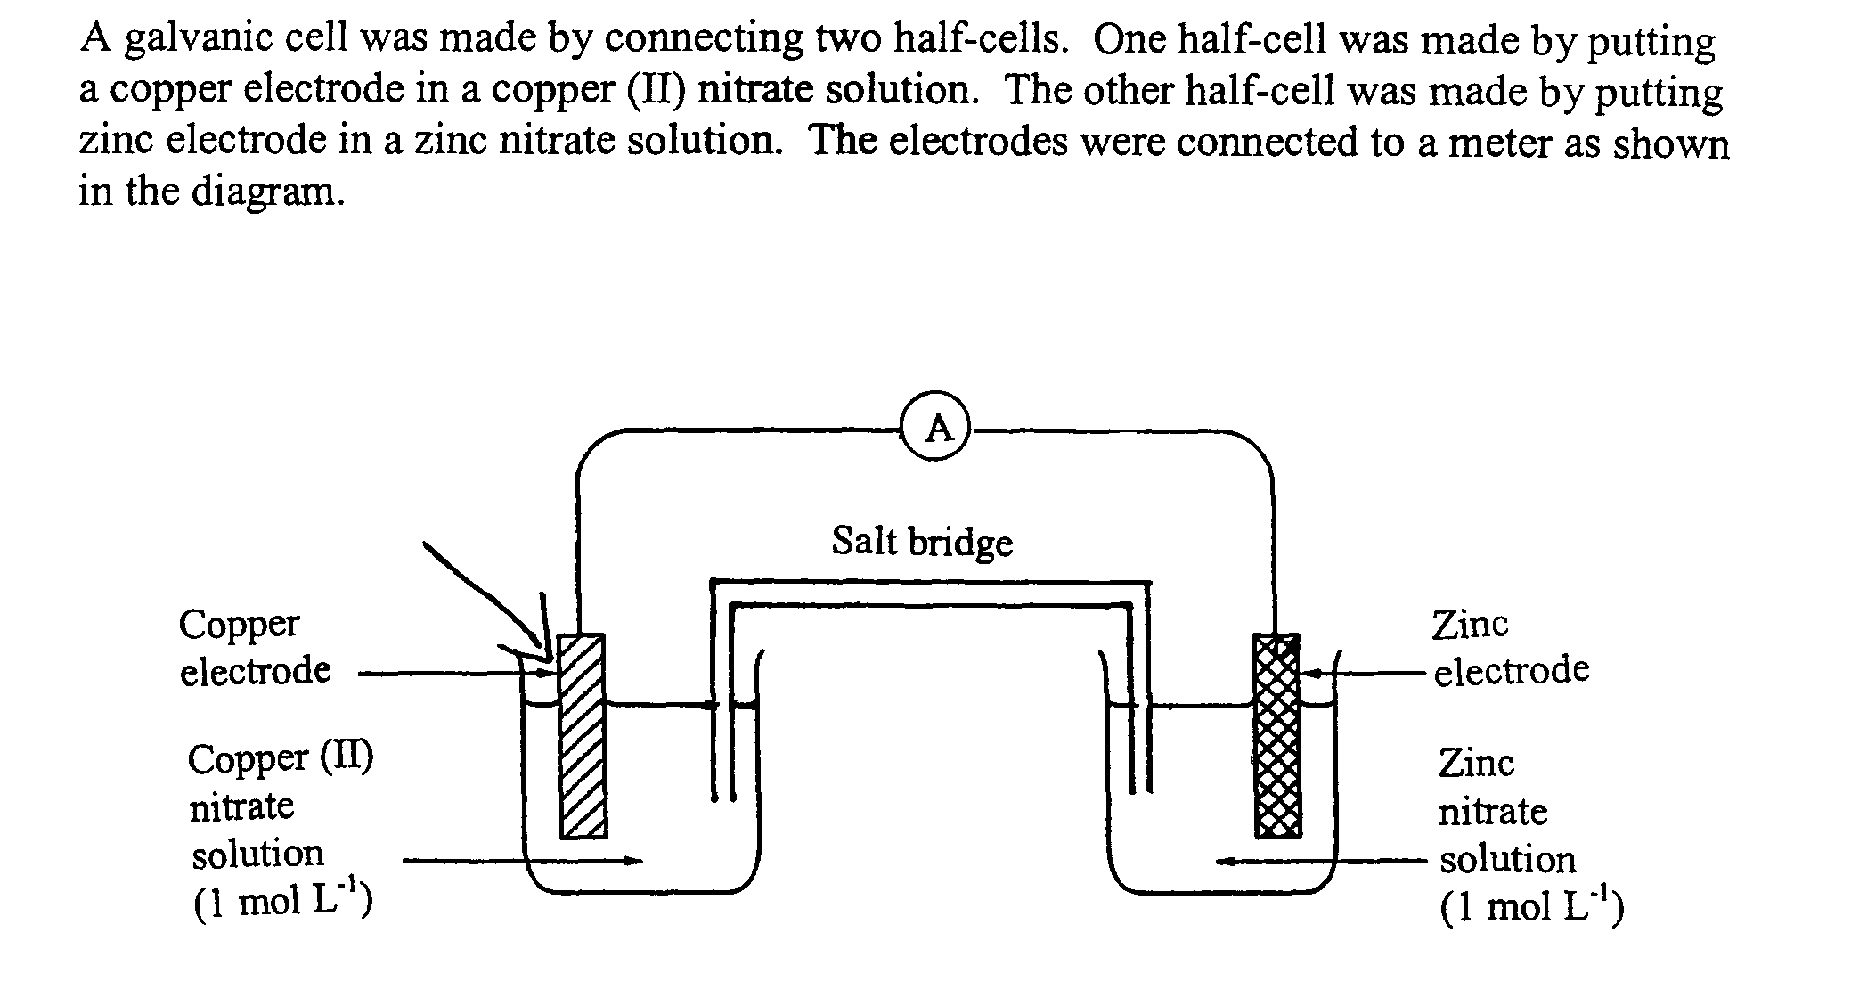

(a) Outline the purpose of the salt bridge 1

……………………………………………………………………………………………………………...

……………………………………………………………………………………………………………...

(b) Using the standard potentials table in the data sheet, calculate the theoretical voltage of this 2
galvanic cell

……………………………………………………………………………………………………………...

……………………………………………………………………………………………………………...
(c) On the diagram label:

(i) anode (ii) cathode (iii) the direction of electron flow
Question 18 (continued)

(d) The copper electrode and the copper (II) nitrate solution is replaced with an iron electrode and a
iron (II) nitrate solution. Identify the cathode and any change to electron flow

……………………………………………………………………………………………………………...

……………………………………………………………………………………………………………...

Question 19 (4 marks)

(a) Identify the instrument that could be used to detect the radiation emitted from a 1
radioisotope such as carbon-14

……………………………………………………………………………………………………………...

(b) Other radioisotopes are used in medicine for both diagnostic purposes and treatment. 3
Identify an example of a radioisotope used and analyse benefits associated with the use
of this radioisotope

……………………………………………………………………………………………………………...

……………………………………………………………………………………………………………...

……………………………………………………………………………………………………………...

……………………………………………………………………………………………………………...

……………………………………………………………………………………………………………...

……………………………………………………………………………………………………………...

Question 20 (3 marks)

When 1.5 L of HCl gas and 1.8 L of NH₃ gas are mixed, a white solid of NH₄Cl is formed. 3
Calculate the mass of NH₄Cl formed if the gas volumes were measured at 25ºC and 100 kPa

……………………………………………………………………………………………………………...

……………………………………………………………………………………………………………...

……………………………………………………………………………………………………………...

……………………………………………………………………………………………………………...
Question 21 (6 marks)

A student set up the apparatus below to determine the molar heat of combustion of 3 liquid alkanols. His results are tabulated below.
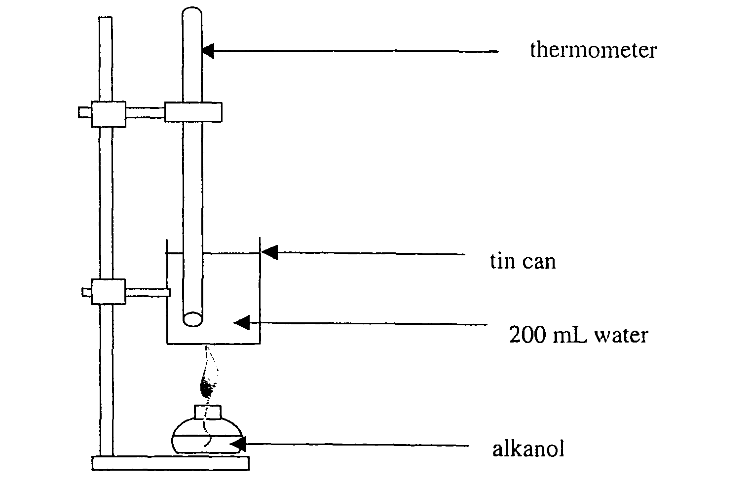
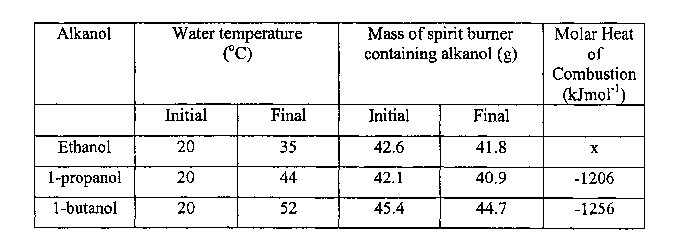

Question 21 (continued)

(a) There is always some risk involved when using a naked flame in a school investigation

Assess ONE of the risks involved in conducting this investigation 2

……………………………………………………………………………………………………………...

……………………………………………………………………………………………………………...

……………………………………………………………………………………………………………...

(b) Calculate the molar heat of combustion for ethanol form the student’s data provided in the table 3

……………………………………………………………………………………………………………...

……………………………………………………………………………………………………………...

……………………………………………………………………………………………………………...

……………………………………………………………………………………………………………...

(c) Explain the trend in heat of combustion for the three alkanols 1

……………………………………………………………………………………………………………...

……………………………………………………………………………………………………………...

Question 22 (4 marks)

Ethane can be cracked to form ethene and hydrogen at 850ºC. The reaction is strongly endothermic

(a) Construct the equation for this reaction 1

…………………………………………………………………………………………………………….

(b) Justify the use of a high temperature for this reaction 1
…………………………………………………………………………………………………………….

(c) Describe what is observed when ethane and ethene gases are bubbled separately through 2
bromine water

……………………………………………………………………………………………………………...

……………………………………………………………………………………………………………...

……………………………………………………………………………………………………………...

……………………………………………………………………………………………………………...

Question 23 (4 marks)

A student used a pH probe and data logger to measure the pH of three different acids, to the nearest integer. Each acid was at a concentration of 0.10 mol/L in aqueous solution. The table below records these measurements:
ACID | pH
Acetic | 3
Citric | 2
Hydrochloric | 1
(a) Compare the hydrogen ion concentration in these three solutions 2

……………………………………………………………………………………………………………...

……………………………………………………………………………………………………………...

……………………………………………………………………………………………………………...

……………………………………………………………………………………………………………...

(b) Account for the differences in these values 2

……………………………………………………………………………………………………………...

……………………………………………………………………………………………………………...

……………………………………………………………………………………………………………...

……………………………………………………………………………………………………………...

Question 24 (3 marks)

Cellulose may be used in the future as the raw material for what we now call petrochemicals

(a) Explain why cellulose cold be a good raw material to build petrochemicals 2

……………………………………………………………………………………………………………...

……………………………………………………………………………………………………………...

……………………………………………………………………………………………………………...

……………………………………………………………………………………………………………...

(b) Cellulose is a condensation polymer of glucose. Explain the meaning of the term 1
condensation polymer

……………………………………………………………………………………………………………...

……………………………………………………………………………………………………………...

……………………………………………………………………………………………………………...

Question 25 (7 marks)

A student was asked to choose accessible equipment that would be suitable for carrying out an investigation involving the fermentation of glucose. The mass change in the fermentation vessel would be monitored.

The student was given a list of specifications for the investigation, as shown below:
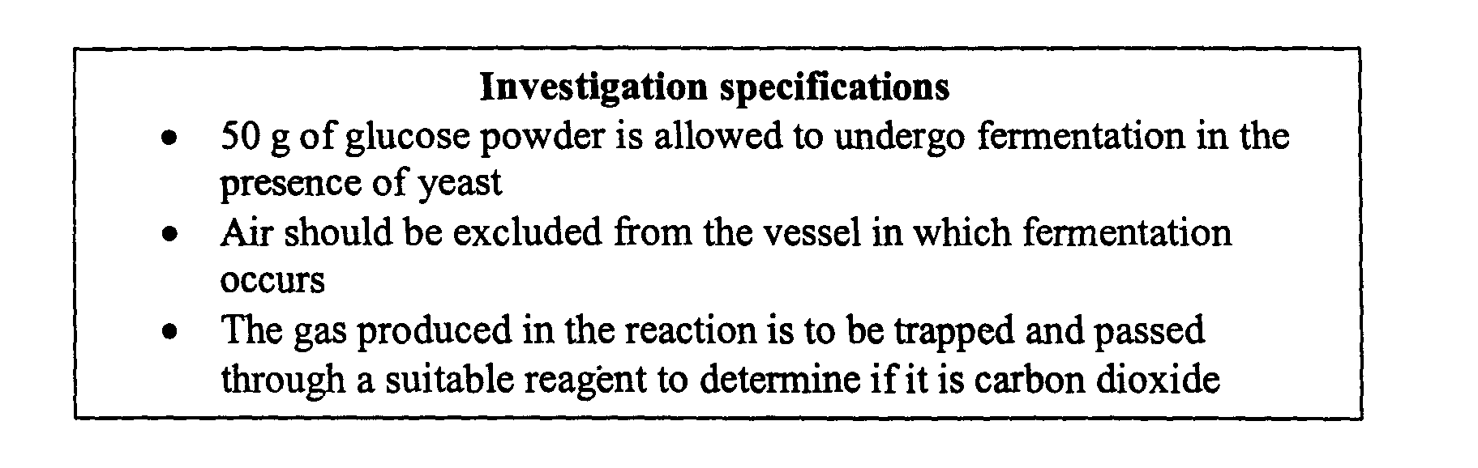

(a) Identify the piece of equipment needed to collect data for this investigation 1

……………………………………………………………………………………………………………...

(b) Make a neat, labelled diagram of the assembled equipment that would meet the above 2
specifications for the investigation

Question 23 (continued)

(c) After 1 day the mass of the fermentation vessel had decreased by 15.0 g

Calculate the theoretical volume of carbon dioxide gas produced if the reaction was carried 3
out at 25ºC and 100 kPa, and state the assumption you made in carrying out the calculation

……………………………………………………………………………………………………………...

……………………………………………………………………………………………………………...

……………………………………………………………………………………………………………...

……………………………………………………………………………………………………………...

……………………………………………………………………………………………………………...

(d) Construct a balanced equation to show the fermentation of glucose, including states 1

……………………………………………………………………………………………………………...

Question 26 (4 marks)

Alkenes, and their derivatives, are important substances in the production of addition polymers.
PVC is an addition polymer

(a) (i) Draw the structural formula of the monomer from which PVC is formed 1

(ii) Give the systematic name of this monomer……………………………………. 1

(b) Identify a use of this polymer and relate this use to its properties 2
……………………………………………………………………………………………………………...

……………………………………………………………………………………………………………...

……………………………………………………………………………………………………………...

Question 27 (4 marks)

Ethanol is used as a fuel extender. Recently, there has been a call from the government to have
ethanol added to all petrol sold in Australia

(a) Draw the structural formula for ethanol 1

(b) Explain the implications of the use of ethanol as a fuel extender 3
……………………………………………………………………………………………………………...

……………………………………………………………………………………………………………...

……………………………………………………………………………………………………………...

……………………………………………………………………………………………………………...

……………………………………………………………………………………………………………...

……………………………………………………………………………………………………………...

……………………………………………………………………………………………………………...

